EXP: 1 WEB PAGE CREATION USING HTML
DATE: 09/01/26
AIM:
To create a web page that embeds a map with hotspot, frame, and links. The web page should be designed using HTML, incorporating embedded, external and inline CSS for styling. This exercise aims to enhance understanding of integrating multimedia elements like maps, creating interacting hotspots, and organizing content using frames while applying different CSS techniques for styling.
ALGORITHM:

Step 1:

Start

Step 2:
Create an HTML document using
<!DOCTYPE html> and <html> tags.

Step 3:
Inside <head> section:
- Set character encoding using <meta charset="UTF-8">
- Set page title as REC - Student Attendance Management
- Add CSS styling for:
  - Background gradient
  - Header styling
  - Navigation bar
  - Hover effects
  - Center alignment
  - Map styling
  - Footer styling

Step 4:
Inside <body> section:
Create a Header Section
- Display college name
- Display system title

Step 5:
Create a Navigation Bar
- Add menu items:
  - Admin Login
  - Student Login
  - Attendance Marking
  - Attendance Report
  - Navigation
- Apply hover effect for interactive design

Step 6:
Create a Center Section
- Display “College Location” heading
- Insert college logo image
- Attach hotspot using:
  - usemap attribute
  - <map> tag
  - <area> tag
- Set hotspot link to Google Maps location
- Open map in new tab using target="_blank"

Step 7:
Embed Google Map
- Use <iframe>
- Paste provided Google Maps embed link
- Set width, height and border styling

Step 8:
Create Footer Section
- Display copyright text

Step 9:
Close all HTML tags properly

Step 10:
STOP
CODE:
<!DOCTYPE html>
<html lang="en">
<head>
<meta charset="UTF-8">
<meta name="viewport" content="width=device-width, initial-scale=1.0">
<title>REC - Student Attendance Management</title>

<style>
body {
margin: 0;
font-family: 'Segoe UI', sans-serif;
background: linear-gradient(135deg, #4e73df, #1cc88a);
}
header {
background: #002147;
color: white;
text-align: center;
padding: 20px;
font-size: 26px;
font-weight: bold;
letter-spacing: 1px;
}
nav {
display: flex;
justify-content: center;
gap: 40px;
background: white;
padding: 15px;
box-shadow: 0 4px 10px rgba(0,0,0,0.2);
}

nav a {
text-decoration: none;
color: #002147;
font-weight: bold;
padding: 8px 15px;
border-radius: 20px;
transition: 0.3s;
}

nav a:hover {
background: #4e73df;
color: white;
transform: scale(1.1);
}
.center {
text-align: center;
padding: 50px 20px;
color: white;
}
.logo img {
width: 200px;
transition: 0.3s;
cursor: pointer;
}

.logo img:hover {
transform: scale(1.1);
}
.map-container {
text-align: center;
margin: 30px;
}

iframe {
width: 80%;
height: 350px;
border-radius: 15px;
border: none;
}
footer {
background: #002147;
color: white;
text-align: center;
padding: 12px;
}
</style>
</head>
<body>
<header>
RAJALAKSHMI ENGINEERING COLLEGE
<br>
Student Attendance Management System
</header>
<nav>
<a href="#">Admin Login</a>
<a href="#">Student Login</a>
<a href="#">Attendance Marking</a>
<a href="#">Attendance Report</a>
<a href="#">Navigation</a>
</nav>

<div class="center">
<h2>College Location</h2>
<div class="logo">
<a href="https://www.google.com/maps/place/Rajalakshmi+Engineering+College/" target="_blank">
<img src="https://www.rajalakshmi.org/_next/image?url=%2Flogo.svg&w=256&q=75" alt="REC Logo">
</a>
</div>
<p>Click the logo to open Google Maps</p>
</div>
<div class="map-container">
<iframe
src="https://www.google.com/maps/embed?pb=!1m18!1m12!1m3!1d3887.4258201029384!2d80.0034695!3d13.008533400000001!2m3!1f0!2f0!3f0!3m2!1i1024!2i768!4f13.1!3m3!1m2!1s0x3a528c9ebac84723%3A0x18e2bf88dfefa3ed!2sRajalakshmi%20Engineering%20College!5e0!3m2!1sen!2sin!4v1771571213473!5m2!1sen!2sin">
</iframe>
</div>
<footer>
© 2026 Rajalakshmi Engineering College
</footer>
</body>
</html>
OUTPUT:
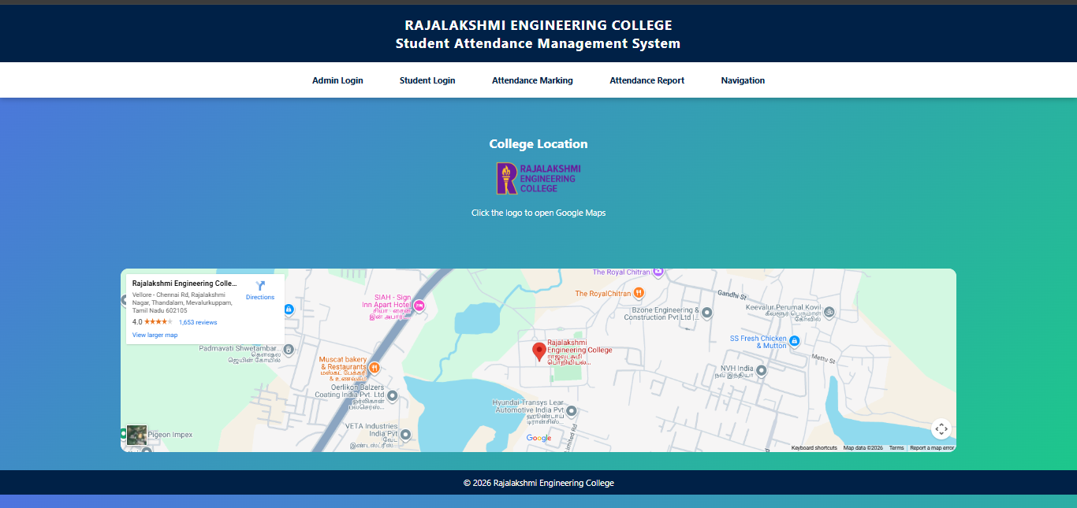

RESULT:
Thus HTML page is created with embedded map along with hotspot, frames and links.

